Database System Engineering and Distributed Backend Development
Course Code: 25CS1302E
06 Data base - Triggers and stored procedures
Name: S. Poojitha reddy
Roll no: 2520030110
Query 1:
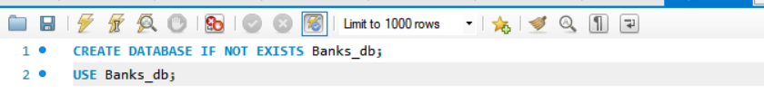
Output:
Query 2:
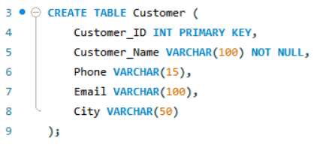
Output:
Query 3:
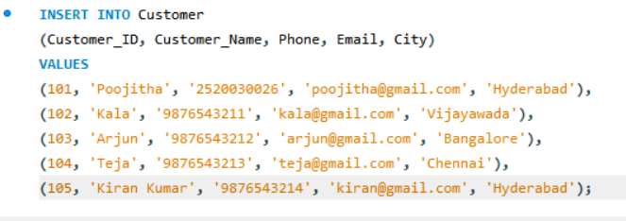
Output:
Query 4:
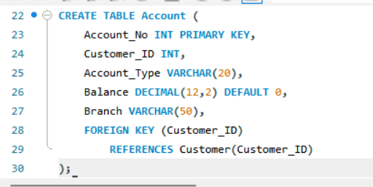
Output: 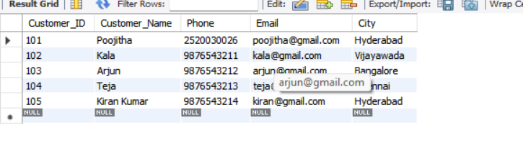

Query 5:
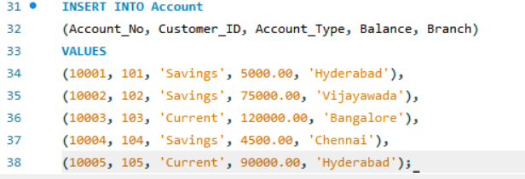
Output:
Query 6:
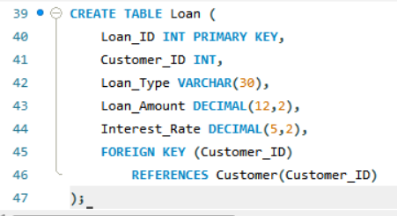
Output:
Query 7:
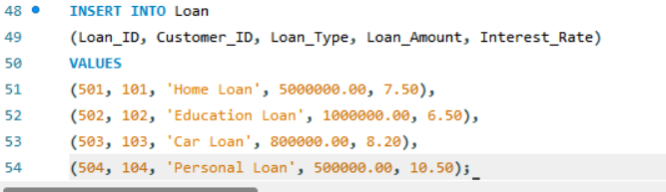
Output:
Query 8:
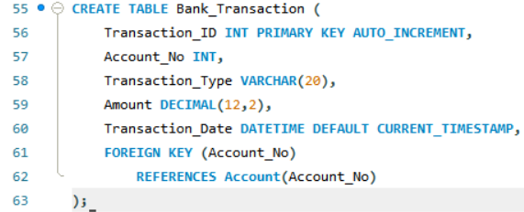
Output:
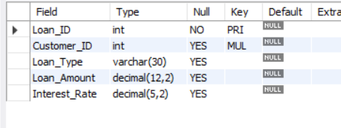
Query 10:
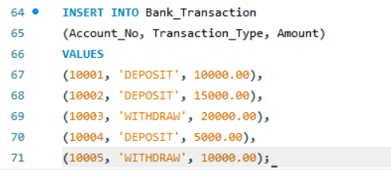
Output:
Query 11:
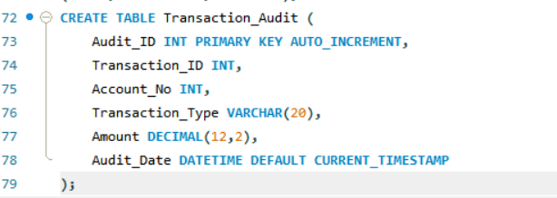
Output:
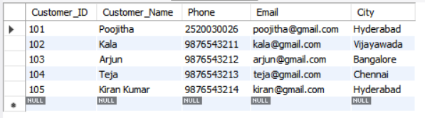
Query 12:
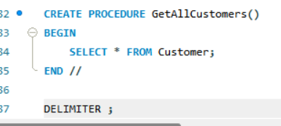
Output:
Query 13:
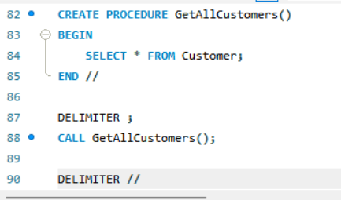’
Output:
Query 14:
Output:
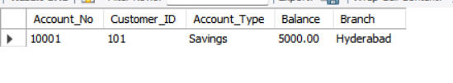
Query 15:
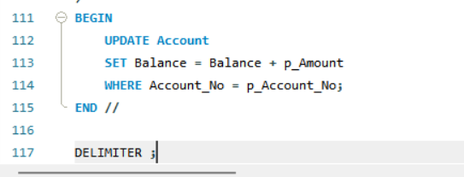
Output:
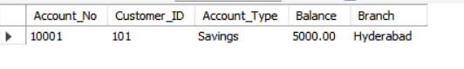

Query 16:
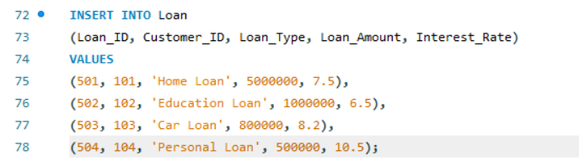
Output:
Query 17:
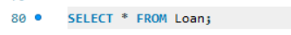
Output:
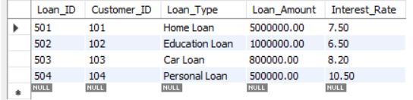
Query18:
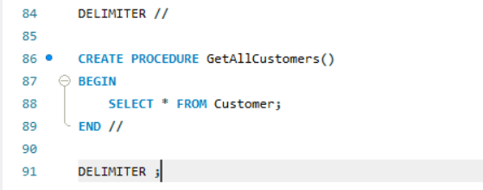
Output:
Query 19:
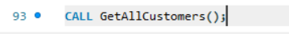
Output:

Query 20:
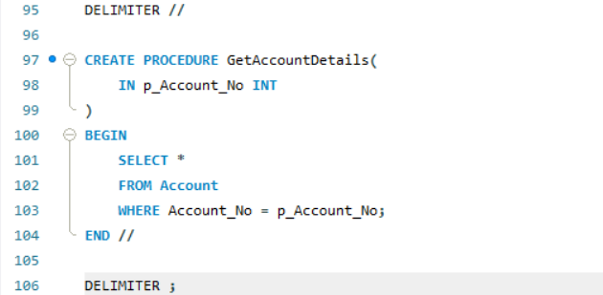
Output:
Query 21:
Output:

Query 22:
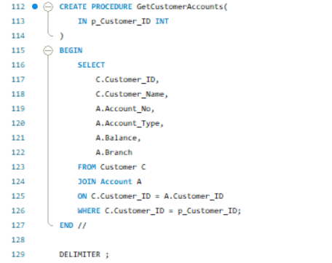
Output:
Query 23:
Output:
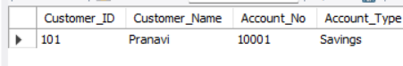
Query 24:
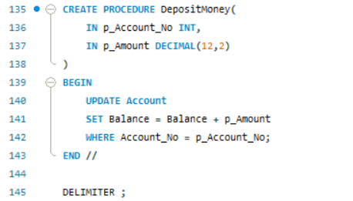
Output:
Query 25:
Output:
Query 26:
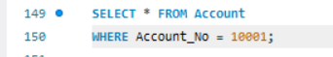
Output:
Query 27:
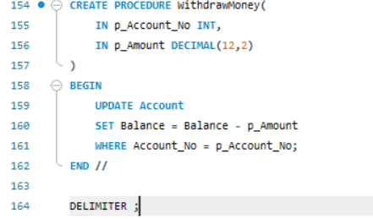
Output:
Query 28:
Output:
Query 29:
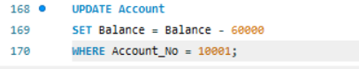
Output:
Query 30:
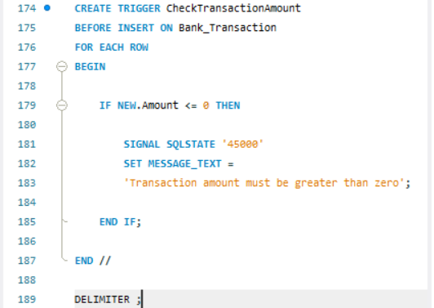
Output:
Query 31:
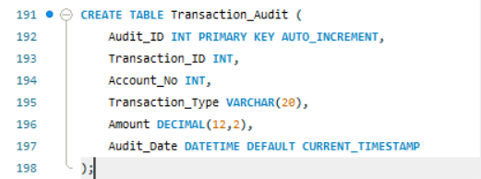
Output:
Query 32:
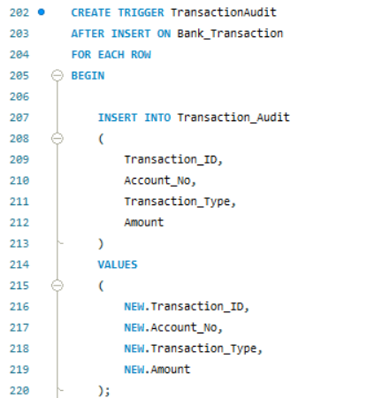
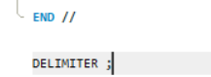
Output:
Query33:
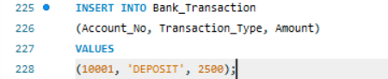
Output:
Query 34:
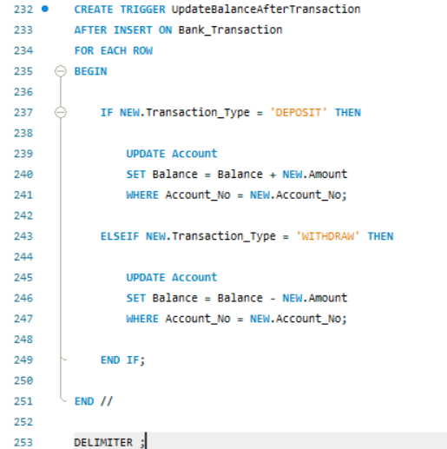
Output:
Query 35:
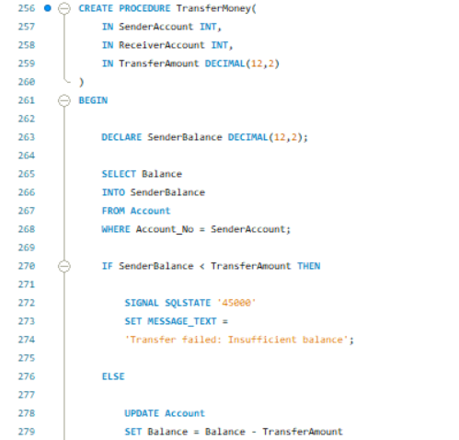
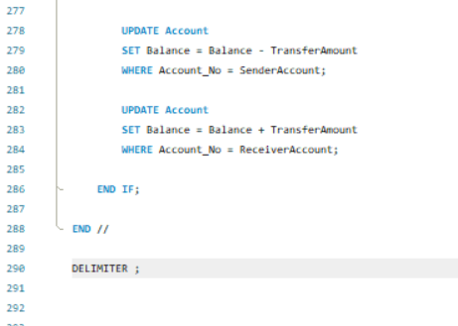
Output:
Query 36:
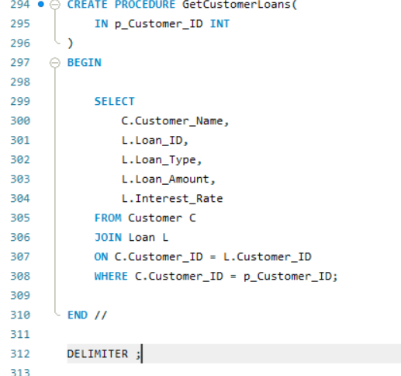
Output:
Query 37:
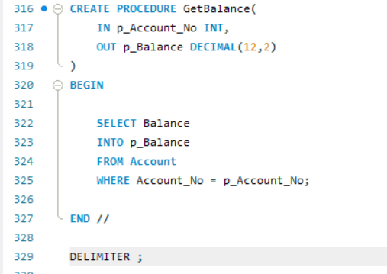
Output:
Query 38:
Output:
Query 39:
Output:
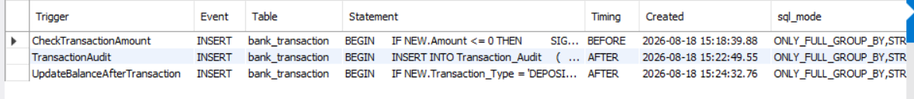
Query 40:
Output:
Query 41:
Output:

